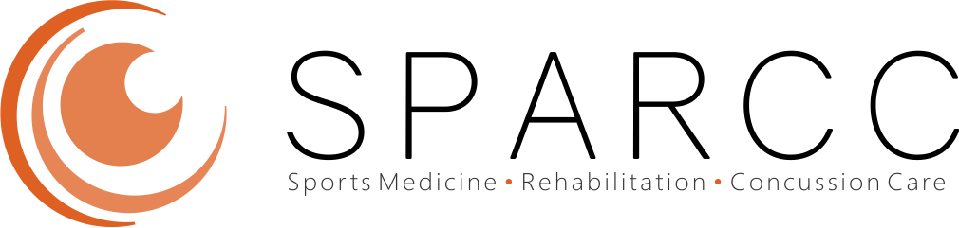
Resident/Student Evaluation

 | 1) Strongly Disagree 2) Disagree 3) Neutral 4) Agree 5) Strongly Agree
- Overall PSM election rotation was very useful for my education. | 1 2 3 4 5
- The provider spent enough time with me. | 1 2 3 4 5
- The provider was knowledgeable. | 1 2 3 4 5
- I would recommend this learning experience without hesitation to others. | 1 2 3 4 5
- There was good teamwork among the providers, nurses, and other staff. | 1 2 3 4 5
- Consults at SPARCC met patient’s expectations/needs/treatment. | 1 2 3 4 5
- I would recommend SPARCC services without hesitation to others. | 1 2 3 4 5

Suggestions for academic/teaching improvements at SPARCC clinics?

Suggestions for patient care improvements in SPARCC clinics?

What SPARCC experience was most/least useful for you?

What non-SPARCC experience was most/least useful for you?

Overall suggestions for the resident/student schedule?

Please leave us with a comment for our website academic page:

